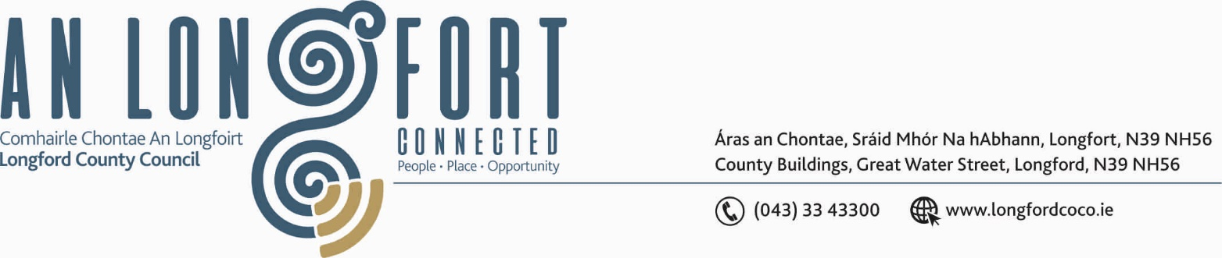

BALLYMAHON MUNICIPAL DISTRICT

Please note meeting will be held via Microsoft Teams.

19th March 2021.

To: Each Member of Ballymahon Municipal District.

Dear Member,

You are requested to attend Meeting of Ballymahon Municipal District to be held
via Microsoft Teams on Thursday, 25th March 2021 at 4.00 p.m. to transact business, as set out on the Agenda hereunder.

Yours sincerely,
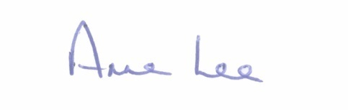

_______________
Anne Lee,
Meetings Administrator.

AGENDA

Prayer before meeting.

1. Confirmation of Minutes of Ballymahon Municipal District -

- Committee Meeting held on the 28th January 2021 – copy enclosed.

- Meeting held on the 28th January 2021 – copy enclosed.

2. Matters arising from Minutes.

3. Declaration of Interest by Members.

4. Management Report - enclosed.

5. Consideration of applications for funding under the 2021 Community Grant
Support Scheme - list enclosed.

6. Consideration of Ballymahon Road Works Programme 2021 – enclosed

7. Notices of Motions, submitted by Councillors, as listed hereunder –

Councillor Pat O’Toole.

“I call on Longford County Council to erect new signage along the various entrances to the Royal Canal Greenway and at the Greenway from Newcastle Bridge to the Royal Canal prohibiting the exercising of horses, this practice is badly damaging the work that has gone into providing an excellent surface for cyclists and walkers not to mention the fouling of the greenways.”

“I call on Longford County Council to provide a disabled parking bay at the HSE health centre upper Main Street Ballymahon”.

Councillor Gerard Farrell

“I call on Longford County Council to erect a street light at a dark corner at Newtowncashel village”.

“I call on Longford County Council Roads Department to look at the possibility of making safe the junction leading to Rathcline Graveyard, Lanesboro as it is very dangerous”.

“That dedicated horse riding trails be incorporated into plans for future development of recreational amenities in cutaway bogs and similar areas”

Councillor Paul Ross.

“I call on Longford County Council to seek funding to repair the bridge/culvert on the L1101 Ardagh Road at the Danes Hill to prevent flooding on this section of road.”



